Lab:03

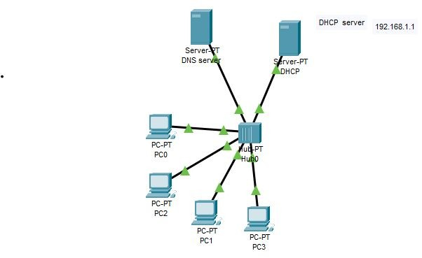**Task:01**

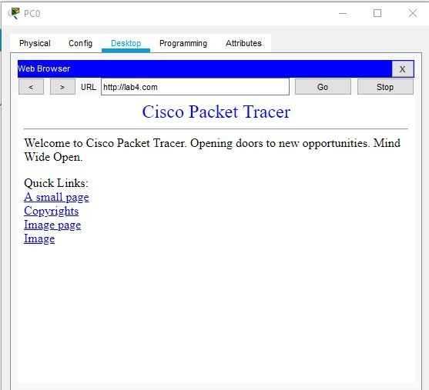

**Task:02**

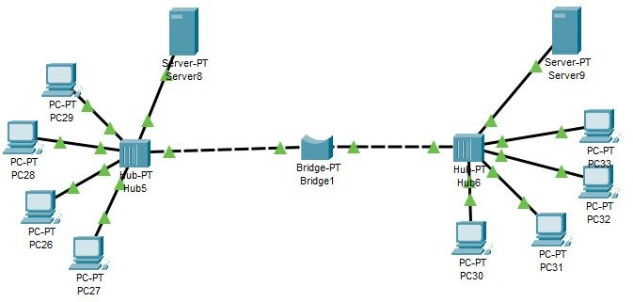**Connection**

**Delivery:**

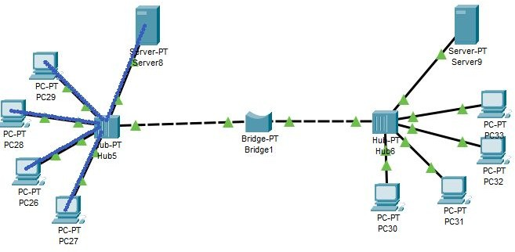

**Status:**

**Working:**

A bridge is a type of computer network device that provides interconnection with other bridge networks that use the same protocol.

In this case, the bridge is connected with 2 hubs which help the hub1 nodes to communicate with hub2 nodes. So the PC’s can communicate from one hub to another hub’s PCs.